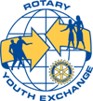
S:\MANAGER\Sincock Files\Rotary Youth Exchange 17 - 18\Outbound - Youth Exchange Informational Flyer 17 - 18.docx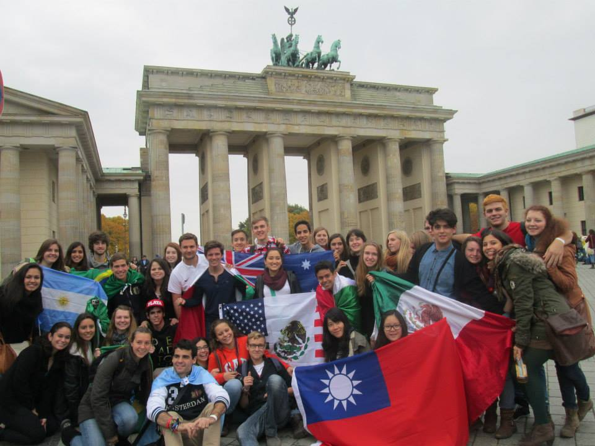
Rotary Outbound Exchange provides students between the ages of 16 and 18 the opportunity of a lifetime! It’s a chance to spend 11 months in another country learning the language and culture. Each year, about 15 boys and girls apply through their local Rotary Club and District 6400. Students generally apply in May through September to go on exchange the next year. Outbound students and their parents are guided through months of orientation and information about the country of their exchange year. Outbound students typically stay with two or three Rotary-approved families and receive a monthly stipend for incidental expenses.
Rotary Youth Exchange outbound students need to be above average students who are eager for the chance to try new things and meet new people. You will learn about other cultures, about other people and about yourself. Contact a Rotary Club today for more information.
Rotary Youth Exchange OUTBOUND Timeline:
- Apply for exchange May – September 2016 for Exchange starting in August of 2017 by using on-line application at http://yehub.net/CEN-obapp
- Rotary Club Interviews student and parents in September/October 2016 and makes recommendation to Rotary District. Rotary District holds interviews of student and parents in late October/November.
- If Student is accepted into the program at the District level the student's application will be sent to Central States Rotary Youth Exchange for processing and country assignment.
- Students find out their Country Assignment in January/February 2017.
- Training for parents and students starts in January/February 2017 and concludes with a the weekend long Central States Conference at Calvin College in Grand Rapids in July of 2017.
- Students leave on Exchange in August of 2017 to return in June/July of 2018.
For more information contact your local Rotary Club or go to www.csrye.org for complete information on participating countries and other information. The cost of the program is approximately $3,100 plus the cost of a round trip one change allowed airline ticket. You can also contact Rotary District Youth Exchange Chairman Paul Sincock at sincock@hotmail.com or by calling 734-455-1388.
